**Lyapunov Exponent**

Lyapunov Exponent is a mathematical characteristic that defines the separation between trajectories of the orbits of certain dynamical systems.

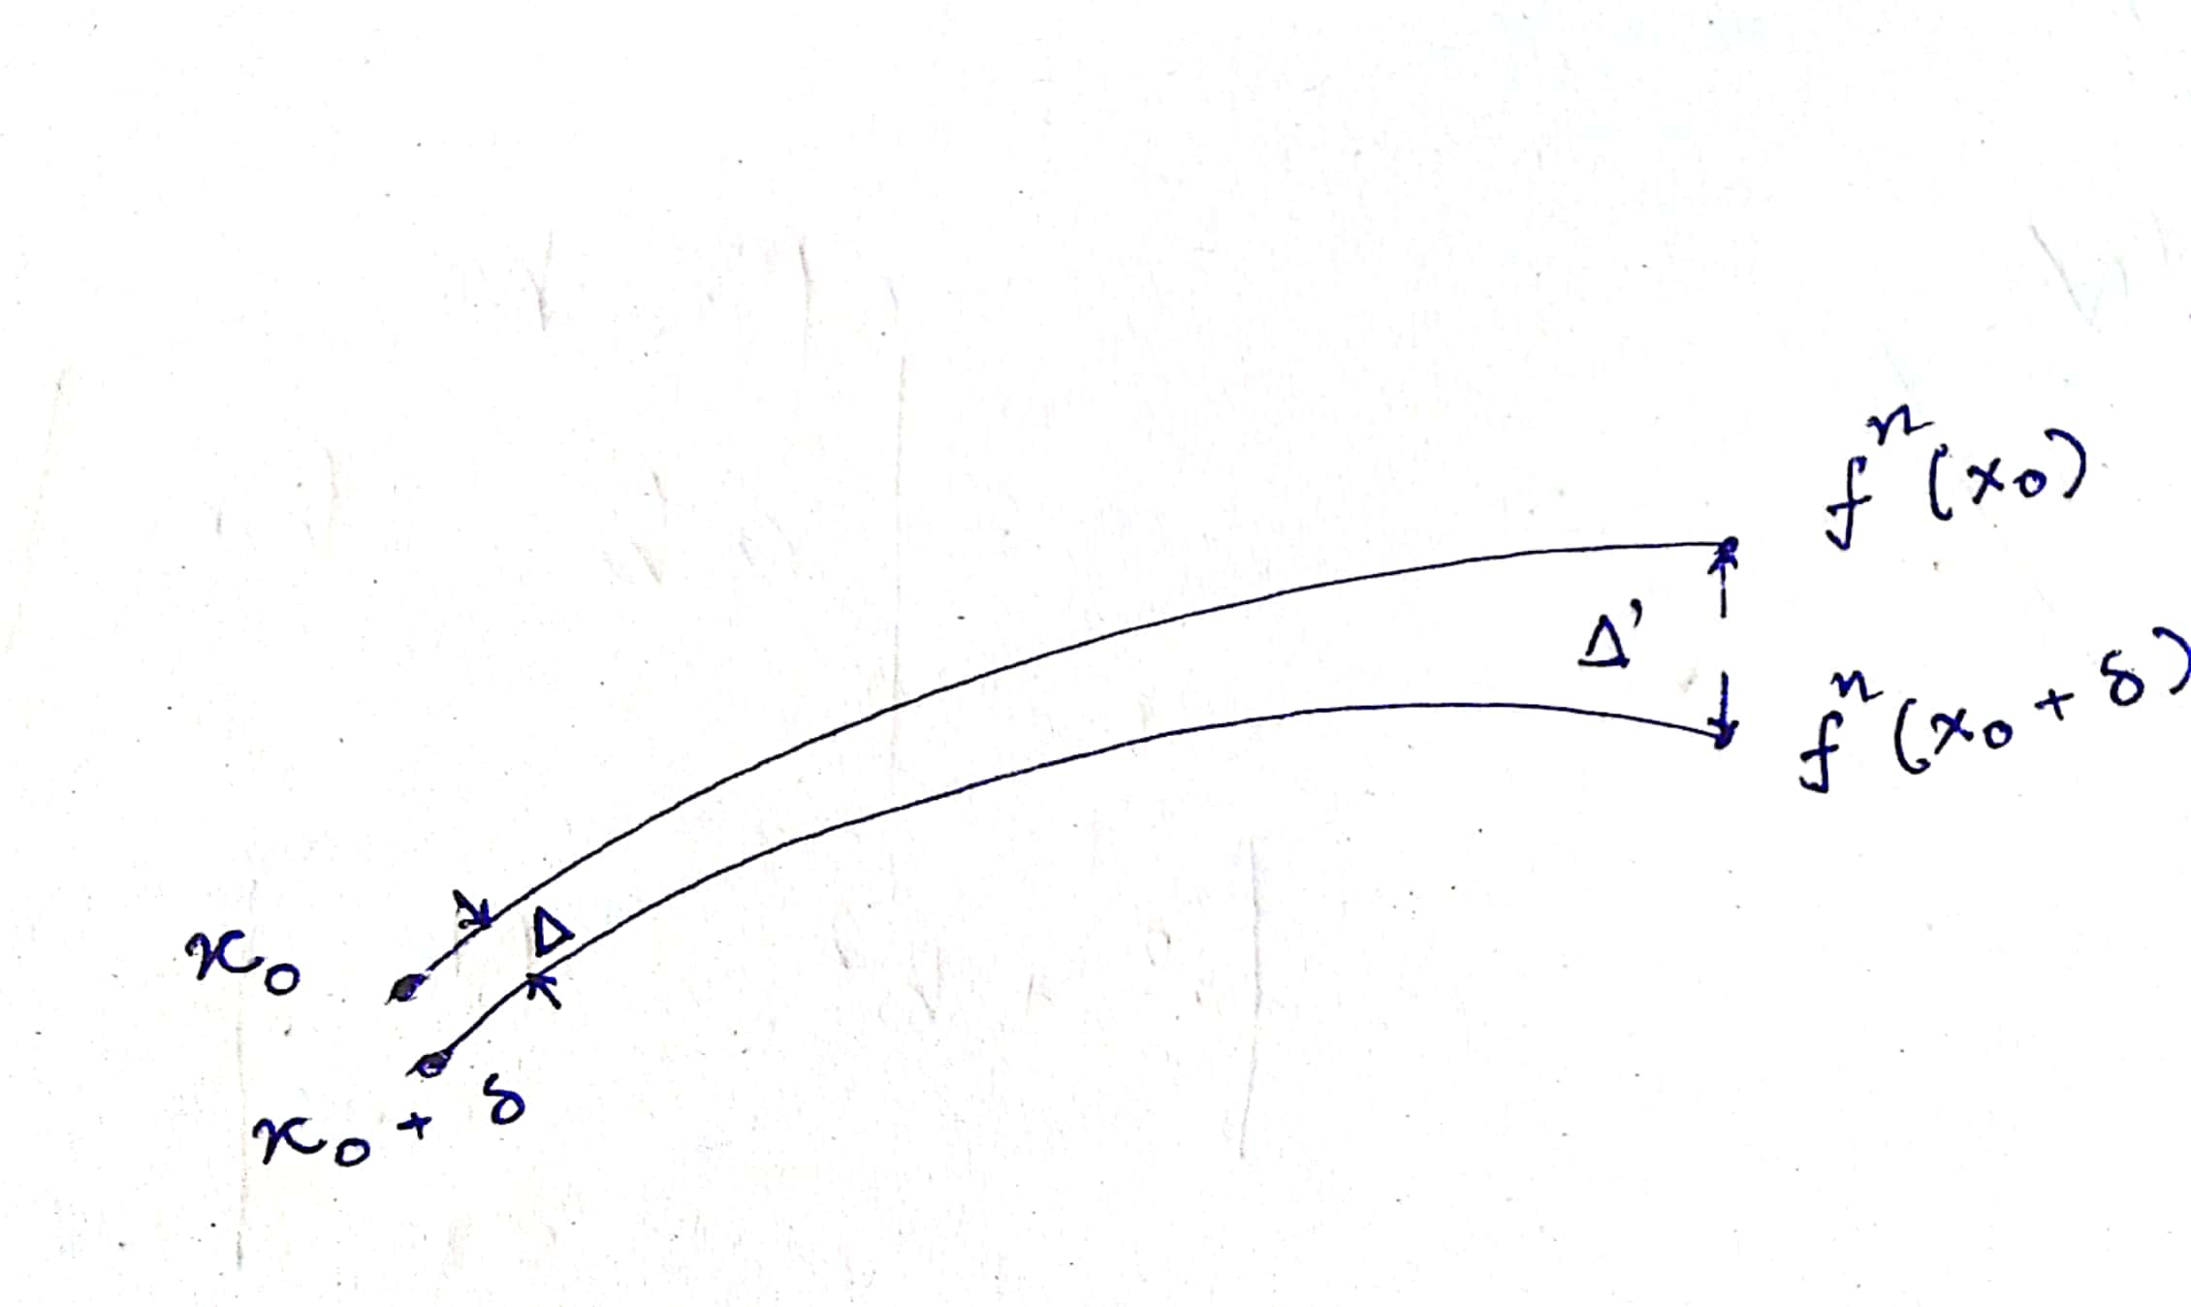

where, $∆^{n}=\left|f^{n}\left(x_{0}+δ\right)-f^{n}\left(x_{0}\right)\right|$ is the separation after $n$ iterations

Initially, the separation was $∆^{0}=\left|x_{0}+δ-x_{0}\right|=δ$

Lyapunov showed that $\left|f^{n}\left(x_{0}+δ\right)-f^{n}\left(x_{0}\right)\right|=δe^{nλ}$

where, $λ$ is the Lyapunov exponent

Further,

$$\frac{\left|f^{n}\left(x_{0}+δ\right)-f^{n}\left(x_{0}\right)\right|}{δ}=e^{nλ}$$

taking $\log_{e}{}$ on both sides to bring down the Lyapunov exponent

$$\log_{e}{\frac{\left|f^{n}\left(x_{0}+δ\right)-f^{n}\left(x_{0}\right)\right|}{δ}}=nλ$$

applying limits on the values of $n$ and $δ$, we get

$$λ=\lim_{n→∞,δ→0}\left(\frac{1}{n}\log_{e}{\frac{\left|f^{n}\left(x_{0}+δ\right)-f^{n}\left(x_{0}\right)\right|}{δ}}\right)$$

Now, this $\frac{\left|f^{n}\left(x_{0}+δ\right)-f^{n}\left(x_{0}\right)\right|}{δ}$ is nothing but $\left({\left.\frac{df}{dx}\right|}_{x=x_{0}}\right)$

$$λ=\lim_{n→∞}\left(\frac{1}{n}\log_{e}\left({\left.\frac{df}{dx}\right|}_{x=x_{0}}\right)\right)$$

Now, we can apply the chain rule of differentiation, like

$$λ=\lim_{n→∞}\left(\frac{1}{n}\log_{e}\left(\left({\left.\frac{df}{dx}\right|}_{x=x_{n-1}=f^{n-1}\left(x_{0}\right)}\right)+\left({\left.\frac{df}{dx}\right|}_{x=x_{n-2}=f^{n-2}\left(x_{0}\right)}\right)+…+\left({\left.\frac{df}{dx}\right|}_{x=x_{0}=f^{0}\left(x_{0}\right)}\right)\right)\right)$$

which could be reformatted as

$$λ=\lim_{n→∞}\left(\frac{1}{n}\log_{e}\left(\sum_{k=0}^{n-1}{\left({\left.\frac{df}{dx}\right|}_{x=x_{k}=f^{k}\left(x_{0}\right)}\right)}\right)\right)$$

We have applied the same algorithm and have developed a python script to calculate the LEs of Chaotic Maps.

1. **Logistic Maps**

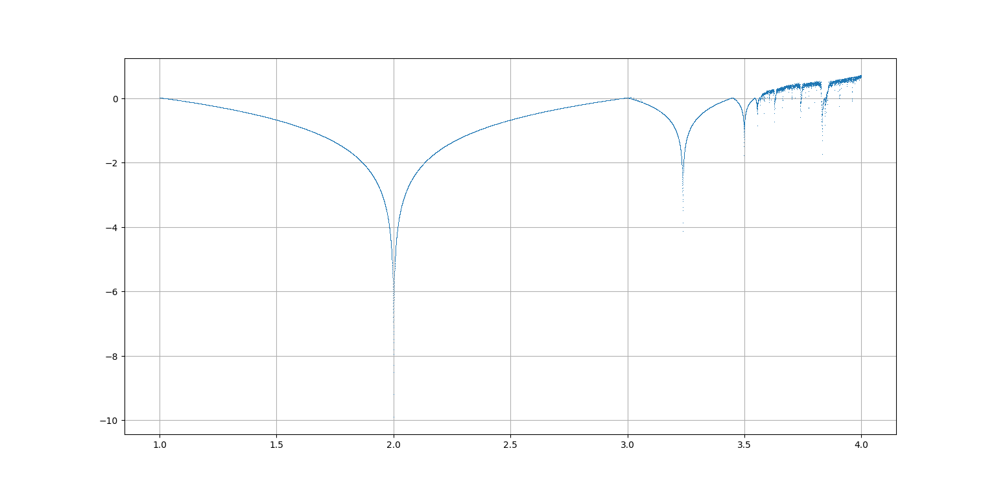

Here, for the Logistic Map, we have considered the $r$ in the range $[0, 4]$.

Also, we have iterated the map 100 times.

1. **Gauss Maps**

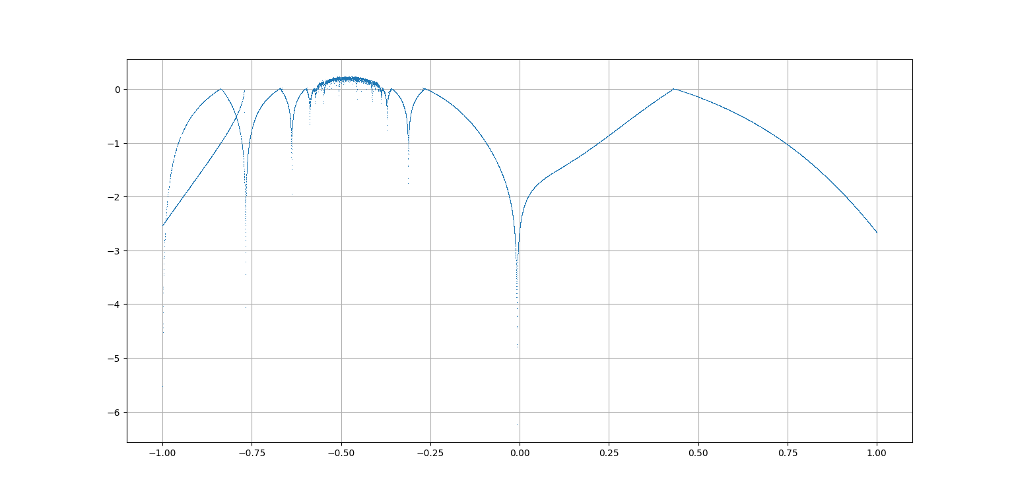

Here, for the Gauss Map, we have considered the $β$ in the range $[-1, 1]$, and $α=4.90$.

Also, we have iterated the map 100 times.